Title

SOP for Genesis agent Installation

Prepared By
Helpdesk

Date: Monday, July 19, 2010

Version 1.0

Document History

Date | Author | Revision | Description
26-10-2010 | MN Kalyan | 1.0 | Document Creation

Approved By: | Tata Business Support Services Limited
Rama Krishna TV | 1.0 | Manager-Technology

Distribution List
Name | Department | Company | Rights
MN Kalyan | Technology | Tata BSS | Review & Comment
Ramakrishna TV | Technology | Tata BSS | Modify
Ali Hyder | Technology | Tata BSS | Review & Approve

Security Classification: Tata BSS Restricted.

Requirements:

1 GB RAM, PIV 2.4 GHz Processor, 40 GB HDD.

EYE BEAM

Procedure:

Go to run command and enter \\10.64.134.21\d$\Genesys\Vs1.0.0.15_10-June-2010\Vs1.0.0.15_10-June-2010\setup.exe

Then you will find the below window

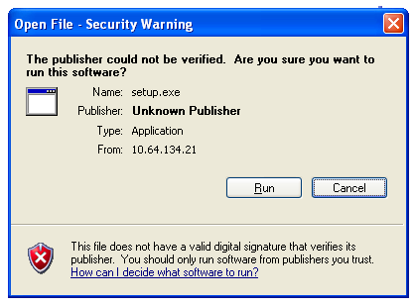

Click on Run button. You will find the below window.
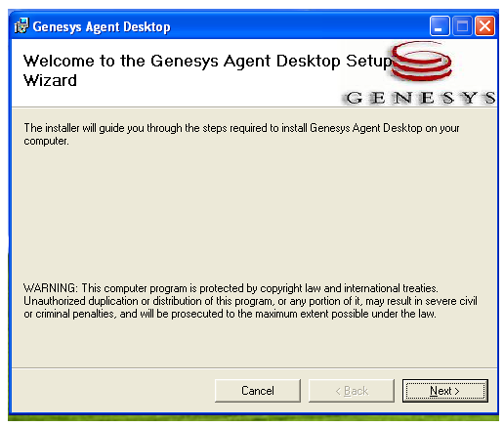

Click on Next.

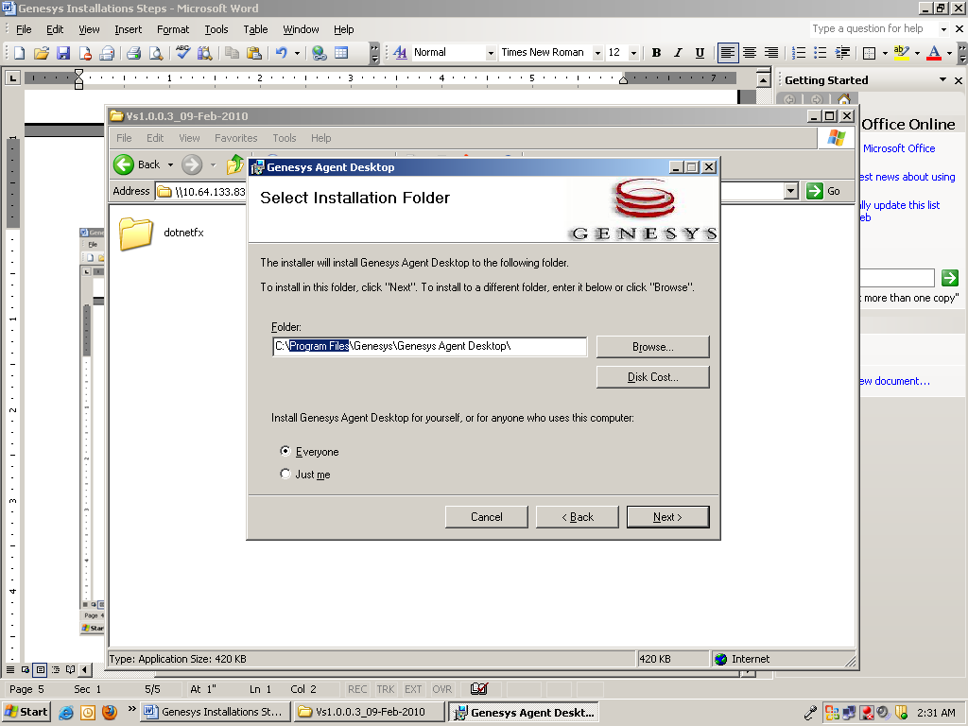

Change GCTI in Place of Programs files

And select next. Then you will find the below window.

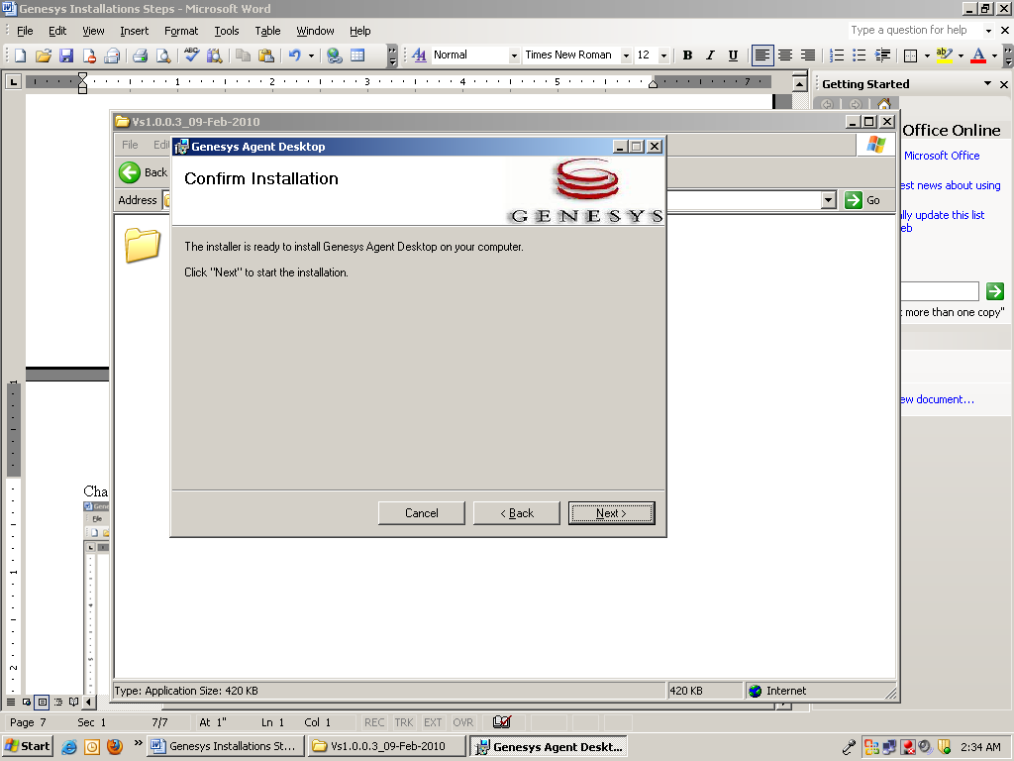

Click on next

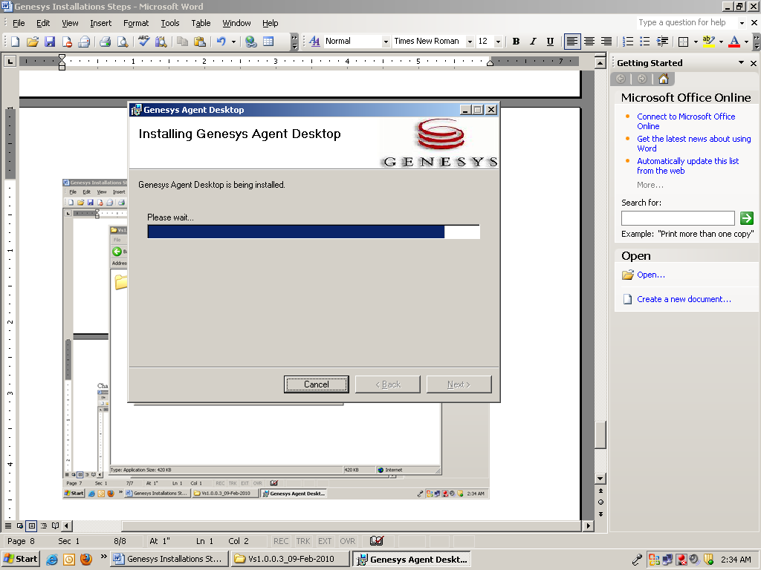

Once the installation gets completed click on finish, and close which completes the installation procedure.

